DSA0601 Data Handling and Visualization
Slot A
CO2 – Assessment Test 1 (AT1)
Chart Construction Test

Question 1 – Healthcare Analytics
Aim
To construct a scatter plot using R (ggplot2) that maps Patient Age on the X-axis, Blood Pressure on the Y-axis, Disease Severity using different colors, and BMI using point size to visualize the health risk of patients.

R Program
# Load the ggplot2 package
library(ggplot2)

# Create the dataset
health <- data.frame(
Patient = c("P1","P2","P3","P4","P5","P6","P7","P8"),
Age = c(24,32,41,48,56,65,38,29),
BMI = c(19.8,24.5,28.1,30.3,33.2,36.5,26.2,22.1),
BloodPressure = c(110,118,132,145,152,168,124,116),
DiseaseSeverity = c("Low","Medium","High","High",
"Critical","Critical","Medium","Low")
)

# Create Scatter Plot
ggplot(health,
aes(x = Age,
y = BloodPressure,
color = DiseaseSeverity,
size = BMI)) +
geom_point(alpha = 0.8) +
scale_color_brewer(palette = "Set1") +
labs(
title = "Healthcare Analytics",
x = "Patient Age",
y = "Blood Pressure",
color = "Disease Severity",
size = "BMI"
) +
theme_minimal()

Visualization
Output: Scatter Plot showing:
- Patient Age on the X-axis
- Blood Pressure on the Y-axis
- Disease Severity represented by different colors
- BMI represented by point size

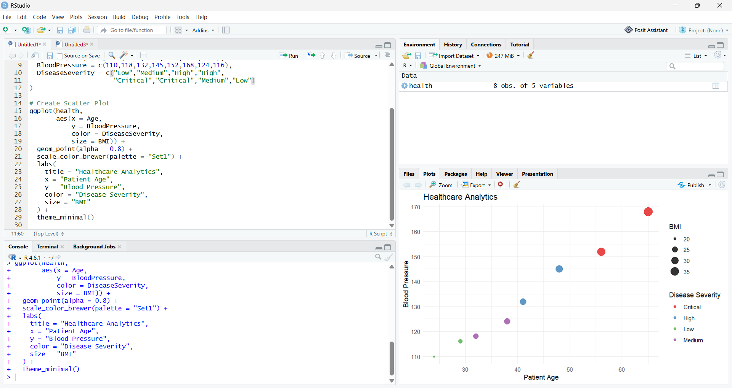

Task (i): Create a scatter plot using the given aesthetic mappings.
Answer:
A scatter plot is created using Patient Age on the X-axis and Blood Pressure on the Y-axis. Disease Severity is represented using different colors, while BMI is represented by varying point sizes. This visualization combines multiple health indicators into a single graph, making patient analysis more effective.

Task (ii): Justify why your aesthetic mappings and scales effectively communicate health risk.
Answer:
- Age is mapped to the X-axis to compare patients across different age groups.
- Blood Pressure is mapped to the Y-axis to identify patients with elevated blood pressure levels.
- Disease Severity is represented using different colors, making it easy to distinguish between Low, Medium, High, and Critical cases.
- BMI is represented using point size, where larger points indicate higher BMI values.
- A categorical color scale and continuous size scale improve readability and help identify patients with multiple risk factors quickly.

Interpretation
The scatter plot effectively displays the relationship between Age, Blood Pressure, BMI, and Disease Severity. Patients with higher age, larger BMI, and higher blood pressure appear more prominent in the visualization, enabling healthcare professionals to identify high-risk individuals quickly. The use of different colors and point sizes enhances the clarity of the chart and supports informed clinical decision-making.

Question 2 – Climate Science

Aim
To develop a Cartesian Line Chart showing monthly temperature variation and a Polar Coordinate Chart representing annual rainfall using R.

R Program 1 – Cartesian Line Chart (Temperature Variation)
# Load package
library(ggplot2)

# Create dataset
climate <- data.frame(
Month = factor(c("Jan","Feb","Mar","Apr","May","Jun",
"Jul","Aug","Sep","Oct","Nov","Dec"),
levels = c("Jan","Feb","Mar","Apr","May","Jun",
"Jul","Aug","Sep","Oct","Nov","Dec")),
Temperature = c(20,23,29,35,39,36,32,31,30,28,24,21)
)

# Cartesian Line Chart
ggplot(climate, aes(x = Month, y = Temperature, group = 1)) +
geom_line(color = "blue", linewidth = 1) +
geom_point(color = "red", size = 3) +
labs(
title = "Monthly Temperature Variation",
x = "Month",
y = "Temperature (°C)"
) +
theme_minimal()

Task (i): Create a Cartesian Line Chart showing monthly temperature variation.
Answer:
A Cartesian Line Chart is created using Month on the X-axis and Temperature (°C) on the Y-axis. The line connects the monthly temperature values, while data points clearly indicate the temperature recorded for each month. This visualization effectively shows the trend and seasonal variation in temperature throughout the year.

Visualization
Output: Cartesian Line Chart showing monthly temperature variation.

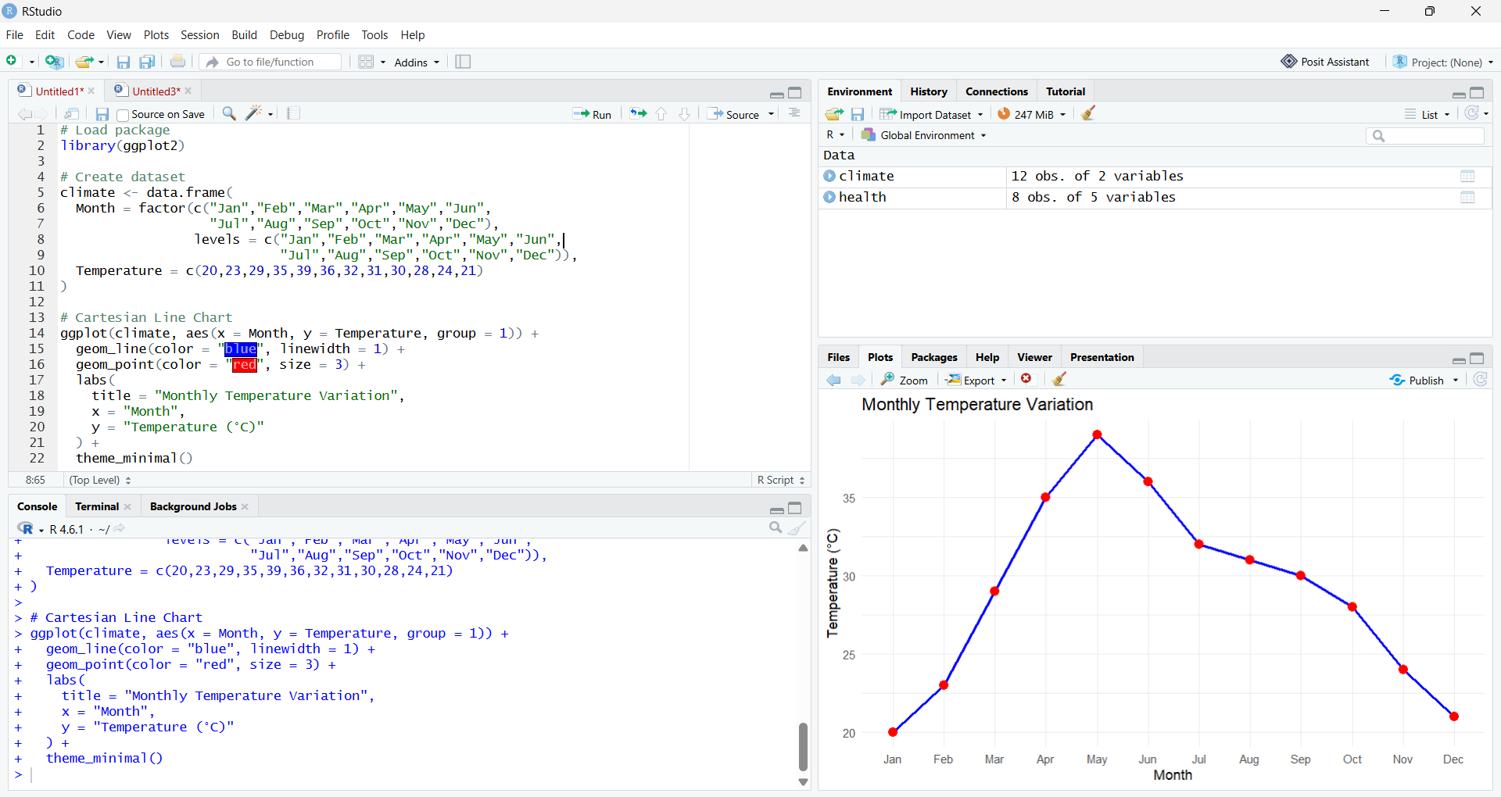

R Program 2 – Polar Coordinate Chart (Annual Rainfall)
# Load package
library(ggplot2)

# Create dataset
rainfall <- data.frame(
Month = factor(c("Jan","Feb","Mar","Apr","May","Jun",
"Jul","Aug","Sep","Oct","Nov","Dec"),
levels = c("Jan","Feb","Mar","Apr","May","Jun",
"Jul","Aug","Sep","Oct","Nov","Dec")),
Rainfall = c(25,18,12,8,5,65,150,170,120,85,45,30)
)

# Polar Coordinate Chart
ggplot(rainfall, aes(x = Month, y = Rainfall, fill = Rainfall)) +
geom_col() +
coord_polar() +
scale_fill_gradient(low = "lightblue", high = "darkblue") +
labs(
title = "Annual Rainfall Distribution"
) +
theme_minimal()

Task (ii): Create a Polar Coordinate Chart representing annual rainfall.
Answer:
A Polar Coordinate Chart is created using Month as the angular axis and Rainfall as the radial value. A blue color gradient is applied to represent rainfall intensity, where darker shades indicate higher rainfall. The circular layout effectively highlights seasonal rainfall patterns throughout the year.

Visualization
Output: Polar Coordinate Chart representing annual rainfall.

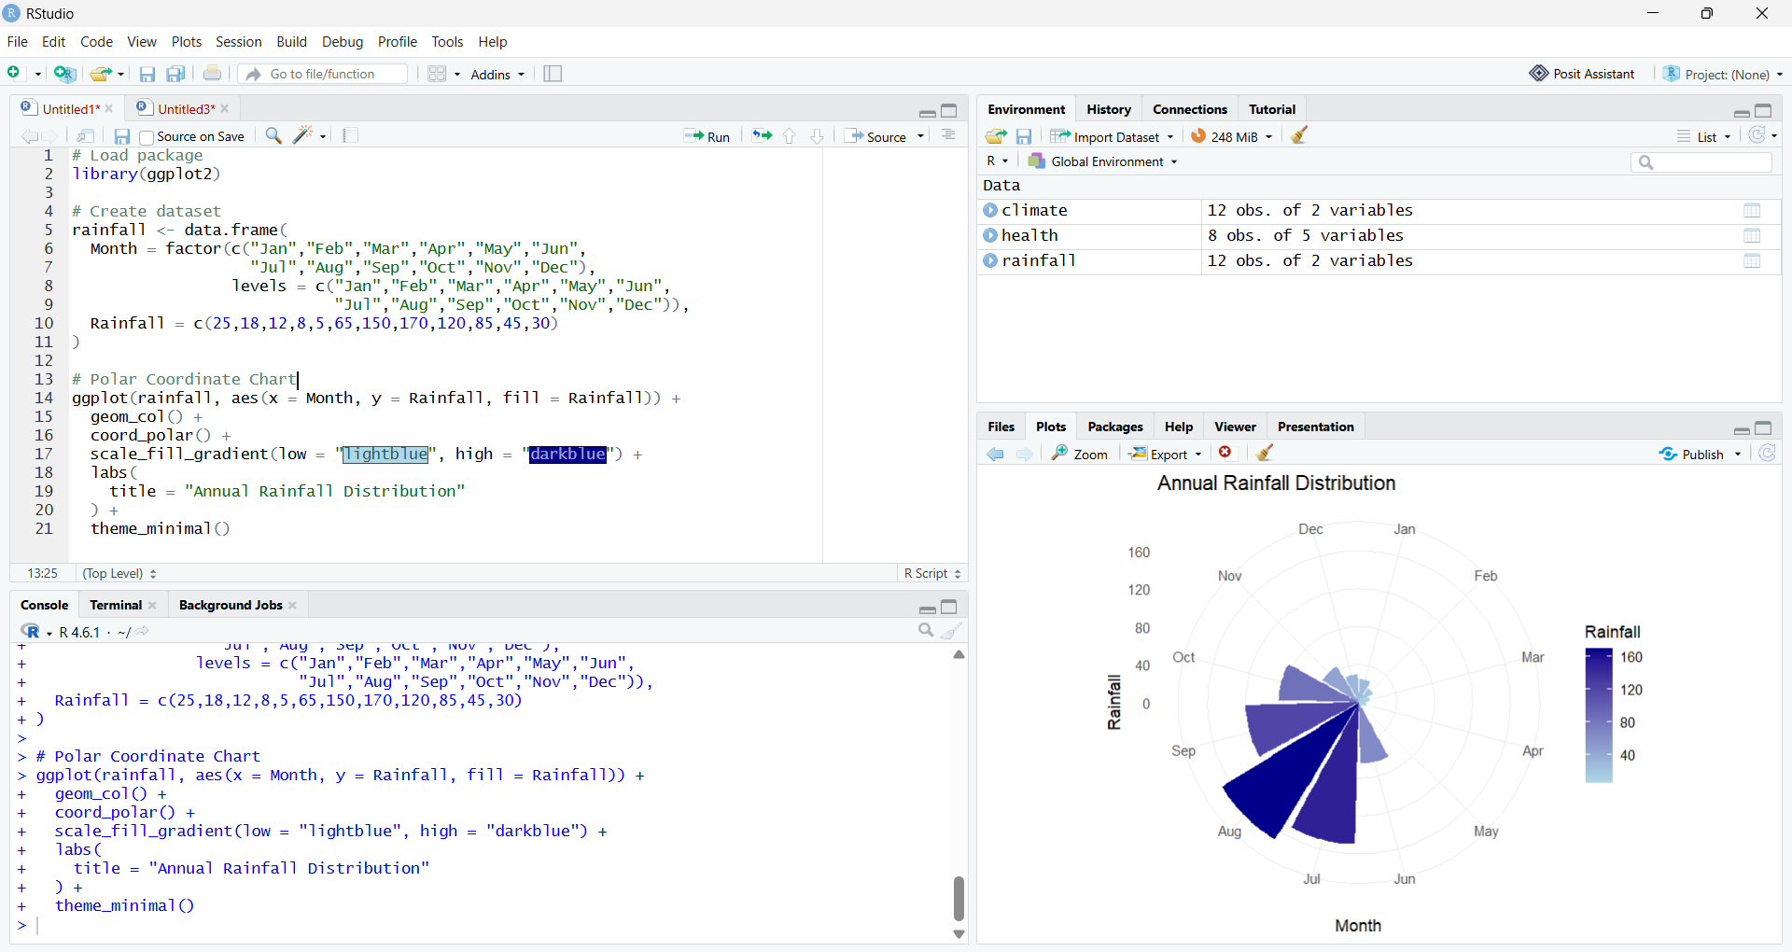

Task (iii): Compare the advantages and limitations of Cartesian and Polar coordinate systems.
Answer:
Cartesian Line Chart
Advantages
- Clearly displays temperature trends over time.
- Makes month-to-month comparison easy.
- Suitable for continuous and time-series data.
- Exact values can be interpreted easily.
Limitations
- Does not emphasize seasonal or cyclic patterns.
- Less effective for representing circular data.
Polar Coordinate Chart
Advantages
- Highlights the cyclical nature of annual rainfall.
- Effectively represents seasonal variations.
- Provides an attractive circular representation of monthly rainfall.
Limitations
- Exact numerical comparison between months is more difficult.
- Small differences in rainfall are less noticeable than in a Cartesian chart.

Interpretation
The Cartesian Line Chart clearly illustrates the variation in monthly temperature, making it easy to observe increasing and decreasing trends throughout the year. The Polar Coordinate Chart emphasizes the cyclical pattern of annual rainfall, making seasonal rainfall distribution more intuitive. Together, these visualizations provide a comprehensive understanding of climate patterns, with the line chart being more suitable for trend analysis and the polar chart being more effective for representing seasonal cycles.

Question 3 – Business Analytics & Marketing
Aim
To construct a bar chart in R where Sales are represented by bar height, Profit Percentage is represented using a sequential color scale, and the product with the highest Market Share is highlighted using a contrasting color.

R Program
# Load package
library(ggplot2)
# Create dataset
business <- data.frame(
Product = c("A","B","C","D","E"),
Sales = c(210,185,260,145,120),
Profit = c(18,14,25,12,10),
MarketShare = c(24,20,28,15,13)
)
# Highlight product with highest market share
business$Highlight <- ifelse(
business$MarketShare == max(business$MarketShare),
"Highest Market Share",
"Other Products"
)
# Create Bar Chart
ggplot(business,
aes(x = Product,
y = Sales,
fill = Profit)) +
geom_col() +
geom_col(data = subset(business, Highlight == "Highest Market Share"),
fill = "red") +
scale_fill_gradient(low = "lightblue", high = "darkblue") +
labs(
title = "Business Analytics and Marketing",
x = "Product",
y = "Sales (₹ Lakhs)",
fill = "Profit (%)"
) +
theme_minimal()

Task (i): Construct a bar chart where Sales are represented by bar height, Profit Percentage by a sequential color scale, and the product with the highest Market Share is highlighted.
Answer:
A bar chart is created with Product on the X-axis and Sales on the Y-axis. The height of each bar represents the sales value of the product. A sequential blue color gradient represents the Profit Percentage, where darker shades indicate higher profit. The product with the highest Market Share is highlighted in red, making it easily distinguishable from the other products.

Visualization
Output: Bar Chart showing:
- Sales represented by bar height.
- Profit Percentage represented using a sequential color scale.
- Product with the highest Market Share highlighted using a contrasting color.

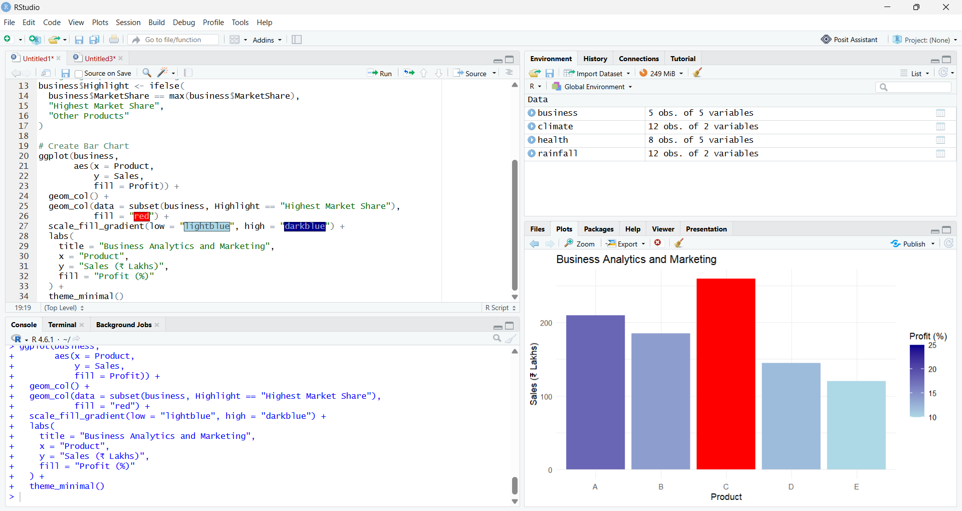
Task (ii): Explain why your chosen color palette improves business decision-making.
Answer:
- A sequential color palette is used to represent Profit Percentage, allowing users to easily distinguish between lower and higher profit values.
- Lighter shades indicate lower profit, while darker shades indicate higher profit.
- The product with the highest Market Share is highlighted using a contrasting red color, drawing immediate attention to the market leader.
- The selected color palette enables managers to quickly compare sales performance, identify profitable products, and recognize the highest-performing product for better business planning and decision-making.

Interpretation
The bar chart clearly compares the sales performance of different products while simultaneously displaying their profit percentages through a sequential color scale. Highlighting the product with the highest market share makes it easy to identify the market leader at a glance. This visualization helps managers evaluate product performance, compare profitability, and make informed decisions regarding pricing, marketing, and inventory management.

Question 4 – Transportation Engineering

Aim
To construct a Polar Coordinate Chart using R to represent traffic flow in different directions and apply an appropriate color palette to distinguish traffic density.

R Program
# Load package
library(ggplot2)

# Create dataset
traffic <- data.frame(
Direction = factor(c("North","North-East","East","South-East",
"South","South-West","West","North-West"),
levels = c("North","North-East","East","South-East",
"South","South-West","West","North-West")),
Vehicles = c(980,1240,1420,860,760,890,1130,720)
)

# Create Polar Coordinate Chart
ggplot(traffic, aes(x = Direction, y = Vehicles, fill = Vehicles)) +
geom_col(color = "black") +
coord_polar() +
scale_fill_gradient(low = "lightgreen", high = "darkgreen") +
labs(
title = "Traffic Flow by Direction",
x = "Direction",
y = "Vehicles per Hour",
fill = "Traffic Density"
) +
theme_minimal()

Task (i): Construct a Polar Coordinate Chart representing traffic flow in different directions.
Answer:
A Polar Coordinate Chart is constructed using Direction as the angular axis and Vehicles per Hour as the radial value. The chart displays traffic flow for all eight directions in a circular layout, making it easy to observe directional traffic patterns.

Visualization
Output: Polar Coordinate Chart representing traffic flow in different directions.
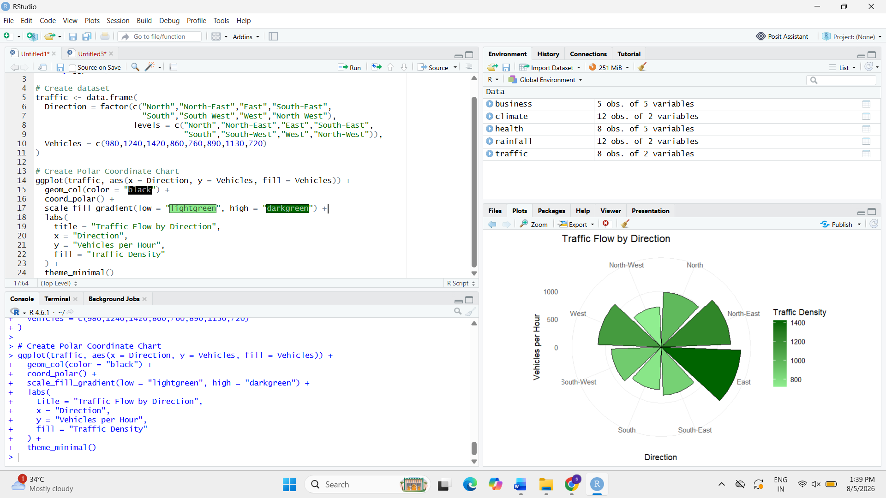

Task (ii): Apply an appropriate color palette to distinguish traffic density.
Answer:
A green color gradient is used to represent traffic density. Lighter shades indicate lower traffic density, while darker shades indicate higher traffic density. This color palette helps users quickly identify highly congested directions and compare traffic intensity across all directions.

Task (iii): Explain why a Polar chart is more suitable than a Cartesian bar chart for directional traffic analysis.
Answer:
- A Polar chart represents directional data in a circular (compass-like) format, making it ideal for traffic flow analysis.
- It preserves the natural relationship between directions such as North, East, South, and West.
- It enables quick identification of traffic congestion from different directions.
- A Cartesian bar chart compares values effectively but does not visually represent directional orientation.
- Therefore, a Polar chart provides better spatial understanding for transportation planning and traffic management.

Interpretation
The Polar Coordinate Chart effectively visualizes traffic flow across different directions. The circular layout reflects the real-world orientation of roads, while the color gradient highlights traffic density levels. Directions with higher vehicle counts appear more prominent, allowing traffic planners to identify congestion-prone routes and make informed decisions regarding traffic control, signal management, and road infrastructure development.

Question 5 – Environmental Sustainability Dashboard

Aim
To design an Environmental Sustainability Dashboard using R that visualizes AQI, Green Cover, CO₂ Emissions, and Population by applying appropriate aesthetic mappings and color scales for effective environmental analysis.

R Program
# Install packages (Run only once)
# install.packages("ggplot2")
# install.packages("patchwork")

# Load libraries
library(ggplot2)
library(patchwork)

# Create dataset
env_data <- data.frame(
City = c("A","B","C","D","E","F"),
AQI = c(48,82,135,165,72,95),
GreenCover = c(45,32,21,18,38,30),
CO2 = c(1.8,3.5,5.6,7.4,2.9,4.2),
Population = c(9,15,22,28,12,18)
)

# Create AQI Categories
env_data$AQI_Category <- cut(
env_data$AQI,
breaks = c(0,50,100,150,200),
labels = c("Good","Moderate","Poor","Very Poor")
)

# Chart 1 - AQI
p1 <- ggplot(env_data,
aes(x = City, y = AQI, fill = AQI_Category)) +
geom_col() +
scale_fill_manual(values = c("green","yellow","orange","red")) +
labs(title = "AQI by City",
x = "City",
y = "AQI",
fill = "AQI Category") +
theme_minimal()

# Chart 2 - Green Cover
p2 <- ggplot(env_data,
aes(x = City, y = GreenCover, fill = GreenCover)) +
geom_col() +
scale_fill_gradient(low = "lightgreen", high = "darkgreen") +
labs(title = "Green Cover (%)",
x = "City",
y = "Green Cover (%)") +
theme_minimal()

# Chart 3 - CO2 Emission
p3 <- ggplot(env_data,
aes(x = City, y = CO2, group = 1)) +
geom_line(color = "blue", linewidth = 1) +
geom_point(color = "red", size = 3) +
labs(title = "CO₂ Emission",
x = "City",
y = "CO₂ Emission") +
theme_minimal()
# Chart 4 - Population
p4 <- ggplot(env_data,
aes(x = GreenCover,
y = CO2,
size = Population,
color = AQI_Category)) +
geom_point(alpha = 0.8) +
scale_size_continuous(range = c(4,10)) +
labs(title = "Population Distribution",
x = "Green Cover (%)",
y = "CO₂ Emission",
size = "Population",
color = "AQI Category") +
theme_minimal()

# Dashboard
(p1 | p2) /
(p3 | p4)

Visualization
Output: Environmental Sustainability Dashboard containing:
- AQI by City
- Green Cover (%)
- CO₂ Emission
- Population Distribution (Bubble Chart)

Task (i): Design a visualization dashboard using AQI, Green Cover (%), CO₂ Emissions, and Population with appropriate aesthetic mappings.
Answer:
An environmental sustainability dashboard is designed by combining four visualizations into a single interface. The dashboard displays AQI, Green Cover (%), CO₂ Emissions, and Population using suitable charts and aesthetic mappings. This integrated view enables easy comparison of environmental indicators across different cities and supports effective monitoring of sustainability factors.

Task (ii): Use suitable continuous scales and apply an appropriate color scale for AQI categories.
Answer:
- A continuous green color scale is used for Green Cover (%), where darker shades represent higher green cover.
- A continuous scale is used for CO₂ Emissions to compare emission levels across cities.
- Population is represented using bubble size, where larger bubbles indicate larger populations.
- AQI Categories are represented using distinct colors:
  - Green – Good
  - Yellow – Moderate
  - Orange – Poor
  - Red – Very Poor
These continuous scales and color mappings improve readability and make environmental comparisons more effective.
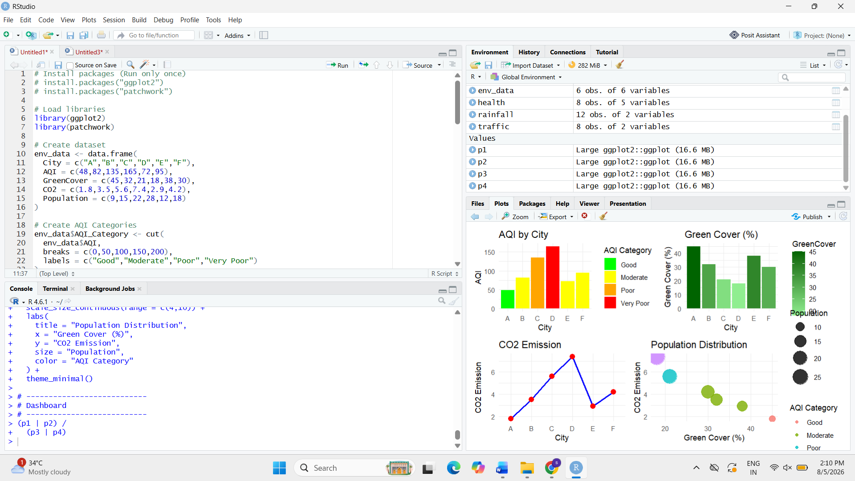

Interpretation
The Environmental Sustainability Dashboard provides a comprehensive overview of multiple environmental indicators in a single view. The AQI chart helps identify pollution levels using distinct color categories, while the Green Cover chart highlights vegetation coverage across cities. The CO₂ Emission chart enables comparison of emission levels, and the Bubble Chart simultaneously represents Green Cover, CO₂ Emissions, Population, and AQI Category. By integrating all these visualizations into one dashboard, users can easily compare cities, identify areas with high pollution or low green cover, and support environmental planning and sustainable decision-making.

S. LAKSHITA
192524108

